PIC Error Dashboard
You will have to copy the following link into the URL:
https://www.hud.gov/helping-americans/public-indian-housing-pic-dashboard

Select: this link on the page.
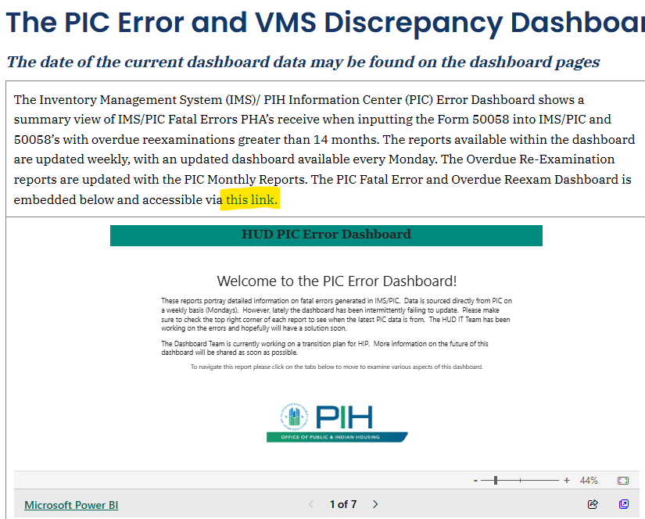

Select: OK (don’t wait for the line to paint)
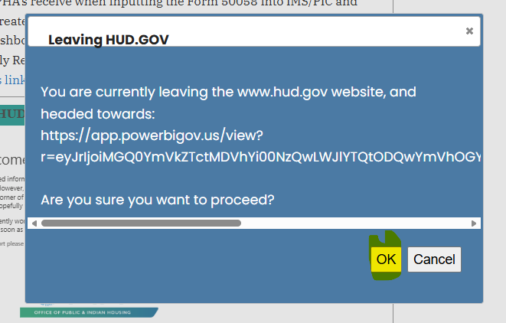

Select the forward > at bottom of page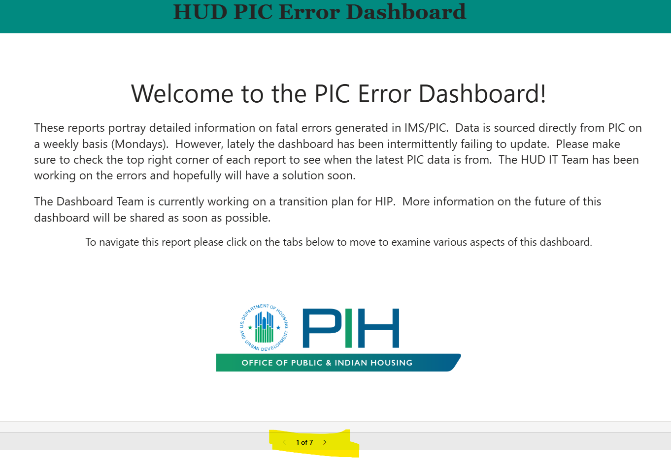

Use the filters to locate your PHA
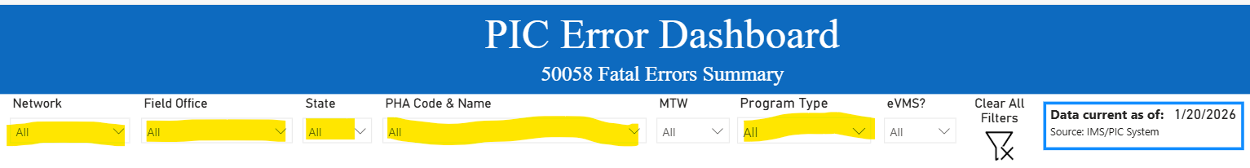
Network: Upper Midwest
Field Office: Minneapolis Hub Office
State: MN
PHA Code & Name: Select PHA from the drop down list
Can also select Program Type or leave it default at ALL
