PIC Error Dashboard & Spreadsheet
Spreadsheet: Required fields
Source the Error Code = 5348 from the PIC Error Report for the PIC Ticket and Form Number.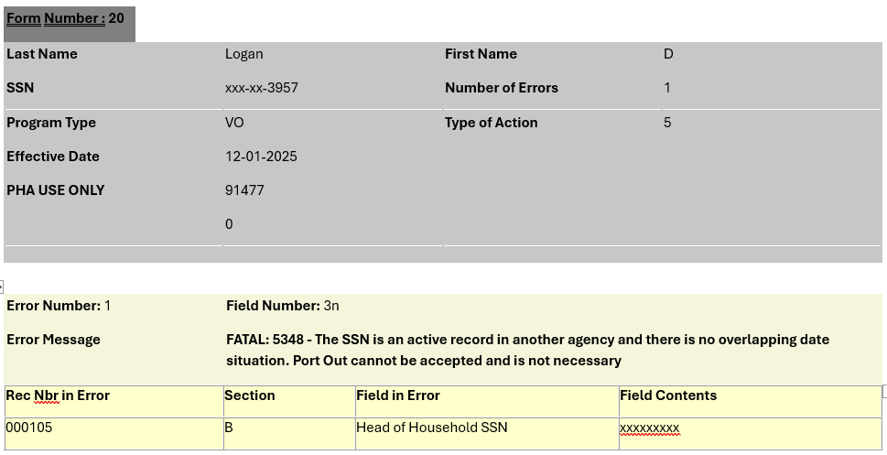

Provide a REASON for requesting the error be removed.
The following is a common response for a rejected Action 5-PO because PIC Auto generated a Port-out action for this household.
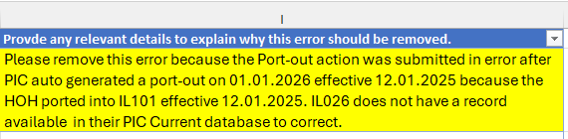
The date PIC auto generated the Port-out can be located in PIC by searching for the HOH under the Historical database under Viewer. The auto Port-out will be the last record posted and the effective date of the auto port-out will be the same effective date the Receiving PHA ported the family in.
You can locate the Receiving PHA Code, action code, and effective date by entering the HOH SSN into HA Query in PIC.

NOTE: The Unique Identifier (1636047520) is the combination of PIC Ticket Number (16360475) and Form Number (20).

